Exercise 4 – Product Stock Alert

Workflow
create_inventory
↓
find_low_stock
↓
generate_alert

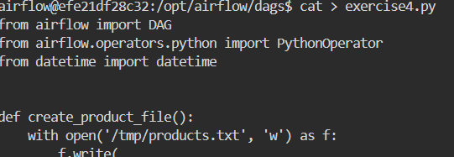

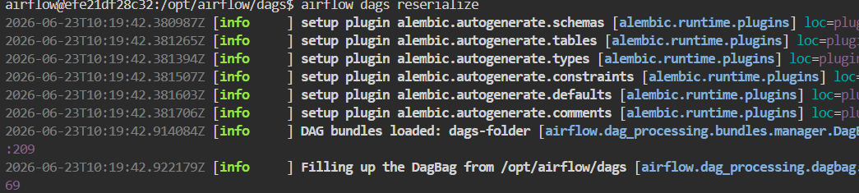

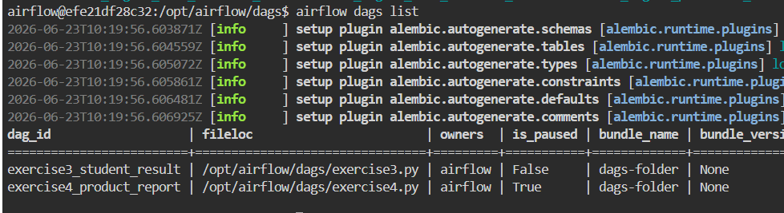

Low Stock Rule
Stock < 15
Output File
/tmp/alerts.txt
Expected:
Oil
Sugar
Tea

Python Code:
from airflow import DAG
from airflow.operators.python import PythonOperator
from datetime import datetime

def create_inventory():
with open('/tmp/inventory.txt', 'w') as f:
f.write(
"Rice,50\n"
"Oil,7\n"
"Soap,35\n"
"Sugar,10\n"
"Tea,5"
)

def find_low_stock():
with open('/tmp/inventory.txt', 'r') as f, open('/tmp/low_stock.txt', 'w') as out:
for line in f:
product, stock = line.strip().split(',')
if int(stock) < 15:
out.write(product + '\n')

def generate_alert():
with open('/tmp/low_stock.txt', 'r') as f:
low_stock_items = f.read()

with open('/tmp/alerts.txt', 'w') as f:
f.write(low_stock_items)

with DAG(
dag_id='exercise4_product_stock_alert',
start_date=datetime(2025, 1, 1),
schedule=None,
catchup=False
) as dag:

task1 = PythonOperator(
task_id='create_inventory',
python_callable=create_inventory
)

task2 = PythonOperator(
task_id='find_low_stock',
python_callable=find_low_stock
)

task3 = PythonOperator(
task_id='generate_alert',
python_callable=generate_alert
)

task1 >> task2 >> task3

Output:

